**LINUX ASSIGNMENT**

1) 1. create the following directory files in the home directory.

mydir1, mydir2 and mydir3

note: use a single command

ANS: mkdir mydir1 mydir2 mydir3

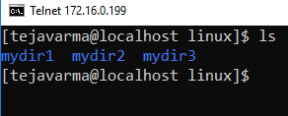

2) 2. create the following directory files:

a. one, two and three under mydir1

b. four, five and six under mydir2

c. seven and eight under mydir3

Ans:

mkdir one two three

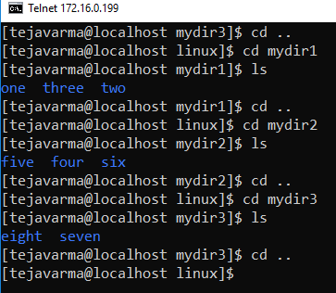

3) go inside five and create a directory file named "nine".

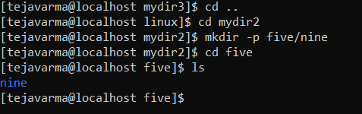

4) go inside eight from five using single command.

Ans:

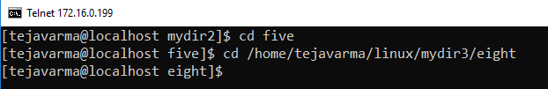

5) create a directory file named "ten" in eight.

Ans:

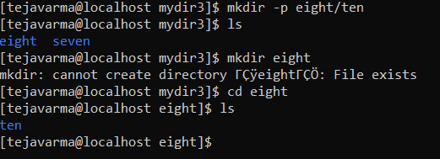

6) create one empty file(file1) inside ten.

Ans:

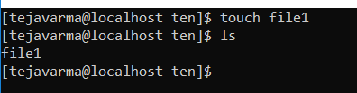

7) create one file (file2) with all week day names inside it in nine directory.

Ans:

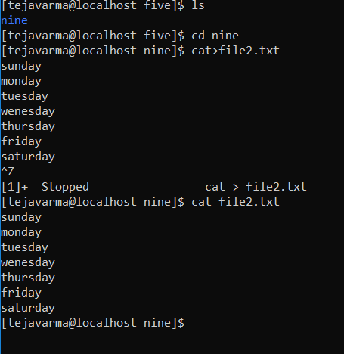

8) copy file2 to directory one using single command.

Ans: 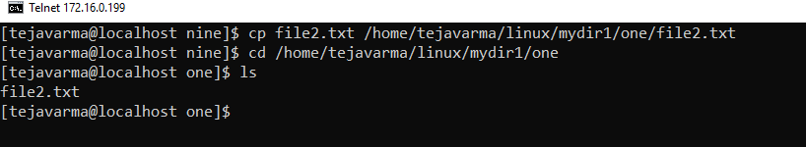

9) move file2 to directory seven using single command.

Ans:

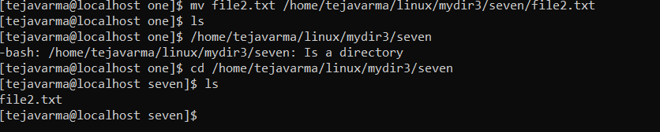

10) create a copy of file2 in it's existing location.

Ans:

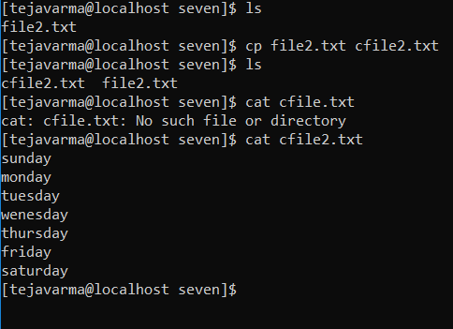

11) show number of lines in file2.

Ans:



12) append all month names inside file1.

Ans:

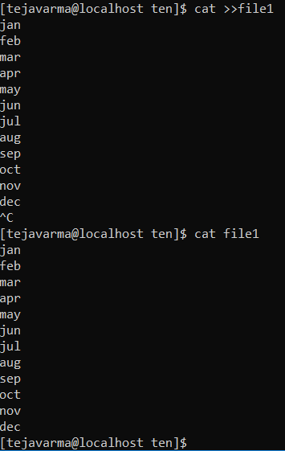

13) show all hidden files in seven directory file.

Ans:

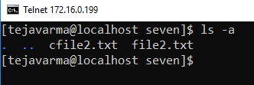

14) show only the subdirectories files in five.

Ans:

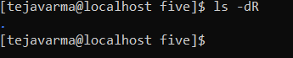

15) display the content of subdirectories also.

Ans:

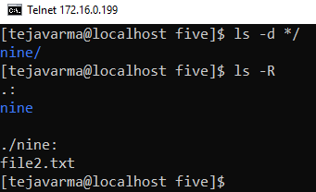

16) display the contents of home directory from directory nine.

Ans:

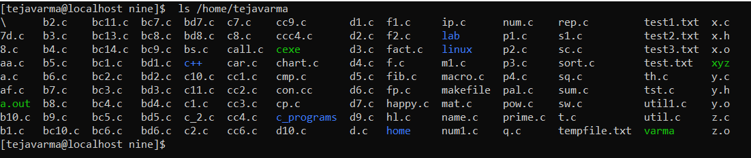

17) display the contents of parent directory.

Ans:

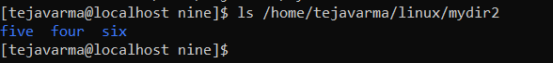

18) move from mydir1 to three using absolute path.

Ans:

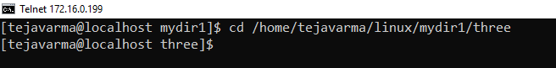

19) move from mydir1 to three using relative path.

Ans:

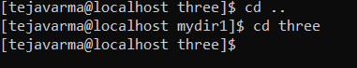

20) move two directories up from nine directory then move to five using a single command.

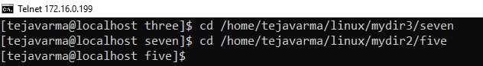

21) remove the directory nine.

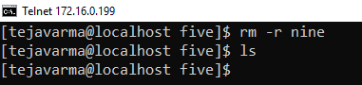

22) show information about pwd command.

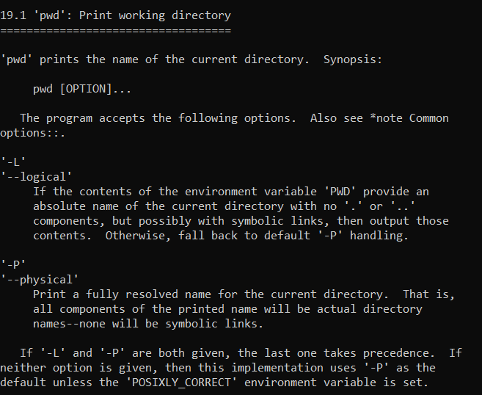

23) display the last 3 lines of a file.

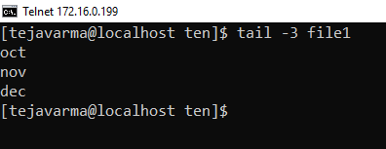

24) display all files with file extension '.sh'.

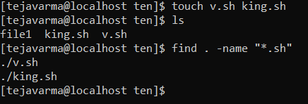

25) give execute permission on test.txt file to others

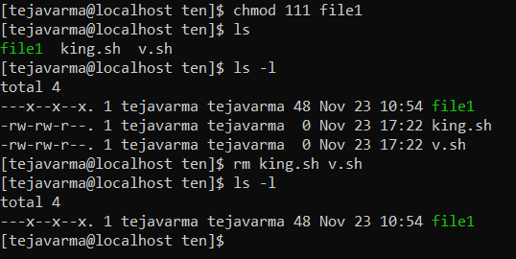

26) give read and write permission on test.txt file to group members.

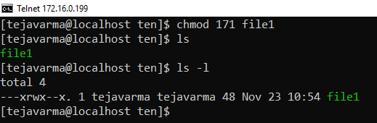

27) revoke write permission on test.txt file from group members.

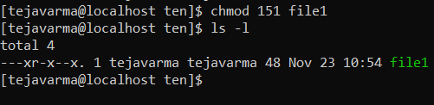

28) add execute permission on test.txt file to the owner of the file.

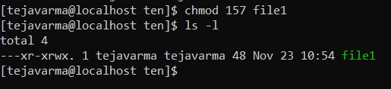

29) set read,write for owner, only read for group members and only execute for others

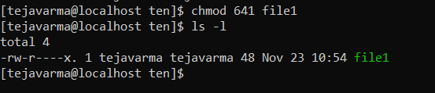

30) using octal permission give read and write permission to owner, only read to group members and read,execute permission to others

